**Theme: Our Country**

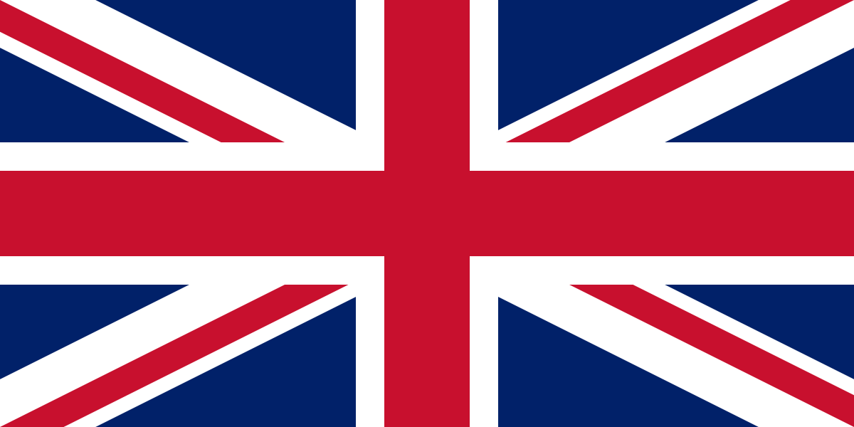

**History Key Vocabulary Chronology: Chronological Order** – A way of arranging actions, events or things according to the time they occurred. **Timeline** – A line that shows the order in which related events happened. **Sequence of events** – The time order in which something of importance takes place. **Historical Knowledge: Cause** - why something happened. **Effect** – something that happened because of something else. **Facts** – information that is true. **Famous** – well known. **Recount** – telling someone about an event or experience. **Research** – investigating to find out facts or conclusions. **Source** – Where something comes from or where it can be found.

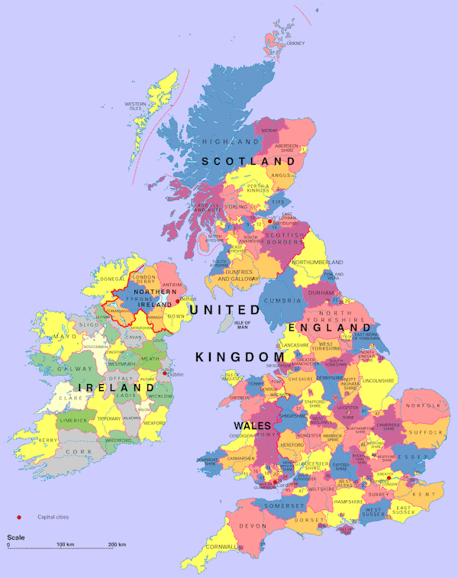

Y2  **Knowledge Builder**

The Great Fire of London broke out just after midnight on 2 September 1666 when Thomas Farriner forgot to put the fire in the oven out. **Fun Fact:**Thomas Farriner's family were stuck upstairs and had to jump out the window so they could escape!

**Geography Key Vocabulary Area** – part of a town, country or the world.

**Community** – a group of people living in the same place.

**Locate** – to discover the exact place or position of.

**Atlas** - A collection of maps.

**Coast/Coastal** – Land near the sea.

**Compare** - To identify the similarities and differences between features or places.

**Compass** - An instrument used for navigation. It shows us **direction** and uses 4 direction points (North, East, South and West).

**Environment** - The surroundings or conditions in which a person, animal, or plant lives.

**Globe** - A spherical model of Earth.

**Human features -** Man-made landmarks, buildings or features that are built by or changed by humans.

**Landmarks** - An object or feature that is easily recognised from a distance. It helps someone to find their location.

**Location** - A place or position.

**Physical features** - A feature formed by nature, features such as mountains, rivers, deserts and oceans.

**Rural** - An area in the countryside.

**Urban** - An area in the city.

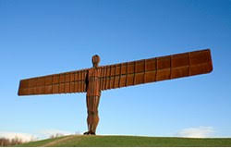

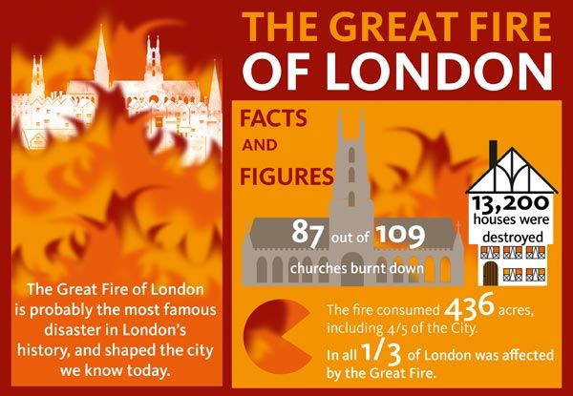

No location in the **United Kingdom** is more than 77 miles away from the sea! In northwest England and the Scottish Highlands are dozens of lakes called **lochs.** These were left behind when the Ice Age glaciers melted.