

**Welcome to the Monthly Bulletin**

The next issue will be out in October

September 2024

**Stannington Infant School PFA**

We have the most wonderful group of parents who support the school by running our Parents Fundraising Association. They raise much needed funds for the children and have bought, amongst other things, The Hive outdoor classroom, outdoor musical instruments and computing equipment. They provide family events like the Christmas and Summer fayre, the Bunny Hunt as well as film nights and non-uniform days. As a small school with children only here for 3 years we are always looking for more support, so if you want to find out more please go along to **PFA meeting at 8.15pm at Minnie’s** **on 13.9.24** All are welcome to attend, have a friendly chat, have a drink and discuss the exciting events coming up in the autumn term. No experience necessary and it’s a great way to meet other parents. We need new members so if you can spare a bit of time to help the school please do come along!

Rainbow & Sunshine Room

Our Integrated Resource is called Rainbow Room and the room alongside is Sunshine Room.

This September we will be welcoming more children into school who have an Education Health Care Plan (EHCP) and have been allocated a place in the IR by Sheffield City Council.

Alongside this we make use of these rooms for children in mainstream school because these are the only spaces we have in school for small group provision.



**Collecting children at home time**

Children are brought out by the class teacher or teaching assistant and will be sent to a parent/carer one at a time. Please can we ask those collecting to acknowledge the teacher and your child with a quick wave. With this in mind please resist the temptation to wave at your child who may be further back in the line.

If your child attends Knowle Top or Nook Lane after school club on set days, please could you let your child's class teacher know what days these are. Likewise, if your child goes home with someone other than yourselves on a regular basis, please could you also let your child's class teacher know who they will be collected by and on what days.

If arrangements change at short notice please notify the school office. Tel 0114 2344401

Please can we ask that the school grounds including the trim trails are **not used** by the children before and after school. Thank you

2.9.24 Inset day

3/4/5/6.9 24 FS transition

5.9.24 Classes open after school 3.20-3.45pm

9.9.24 Classes open after school 3.20-3.45pm

9.9.24 9.30 am Reading Volunteer Workshop in the school hall

13.9.24 PFA meeting at 8.15pm at Minnie’s. Everyone welcome!

3.10.24 Individual photos

7/8/10 24 Toys workshop

18.10.24 Y2s to Giddy Goat

22.10.24 Parents evening – 1:1 meetings with class teachers, parents only please

23.10.24 PFA Bags to School collection

24.10.24 Non uniform day – £1.00 donation to PFA fundraising please

22.10.24 Parents evening – 1:1 meetings with class teachers, parents only please

25.10.24 Inset Day – no pupils in school

28.10.24 Half term

7.11.24 / 14.11.24 / 15.11.24 20.22.24 21.11.24 22.11.24 SEND reviews

29.11.24 Christmas Fayre after school

12.12.24 Christmas Jumper Day (NSPCC)

13.12.24 Christmas Party day

20.12.24 Non uniform day – £1.00 donation to PFA fundraising please

20.12.24 End of term

Christmas Performance dates to follow soon

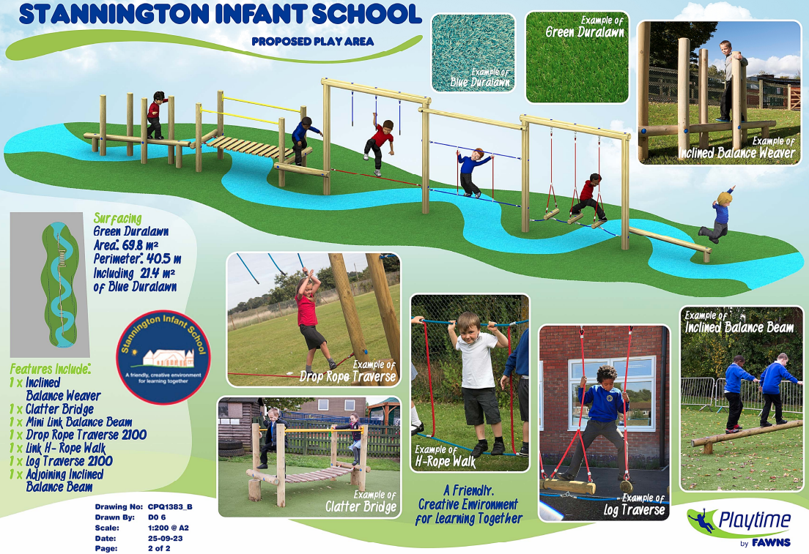

Wonderful event happening at Stannington Library on

Saturday 14th September

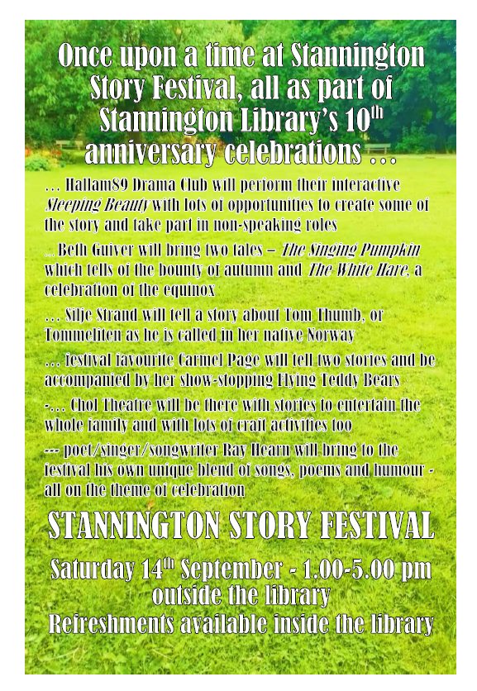

**Stannington Infant School’s**

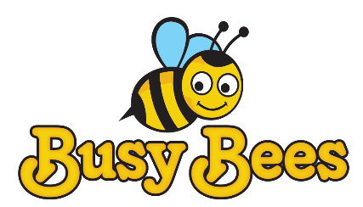

**Breakfast and After School Club**

**Breakfast Club** Monday to Friday 7.30 – 8.50am

**After School Club** Monday to Friday 3.15 – 5.45pm

We provide excellent wrap around provision within a safe and happy environment.

The sessions are charged at £5 for breakfast club which is open from 7.30 am. Each child will receive a healthy breakfast and a drink with quiet space and activities so they are ready for the start of school. Children will be accompanied to the classroom 8.40 am ready for registration.

After school club is available from 3.15pm until 5.45pm, the sessions are charged at £8.50. The children will have access to both indoor and outdoor facilities, making use of our wonderful school grounds. Indoor activities include craft, colouring, baking, whilst outdoors children will have balance bikes, gardening or sporting fun. A healthy snack will be available e.g. fruit or vegetables, toast, smoothies or milk.

All bookings must be made using the Parentmail app booking system and you must use the PAY NOW option unless you are using childcare vouchers in which case you may use the PAY LATER option. All bookings must be paid for upfront and you will receive a refund if you cancel 48 hours in advance.

We have 20 places and cannot accommodate more children at this time. Places will only be allocated upon receipt of the registration form.

Please note that spaces are limited so ensure you request a place in plenty of time.

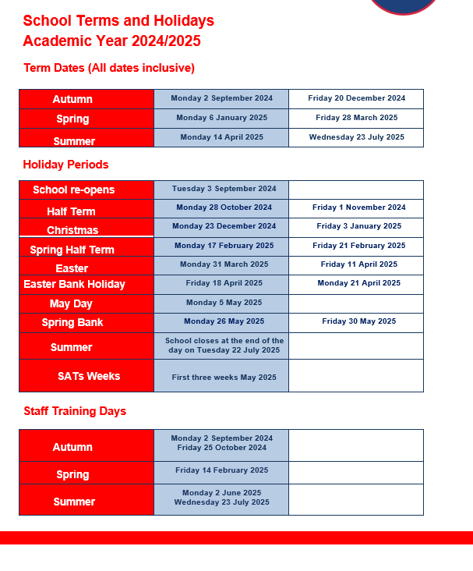

**Contact us ……. Stannington Infant SchoolStannington Road, Sheffield, S6 6AN**

**Telephone: 0114 2344401 Headteacher: Sarah Binns**

**Fax: 0114 2334724 Deputy Headteacher: Liz Harris**

**Email:** [**enquiries@stannington.sheffield.sch.uk**](mailto:enquiries@stannington.sheffield.sch.uk) **Chair of Governors: Charlotte Surridge**

**Website: www.stanningtoninfants.co.uk**