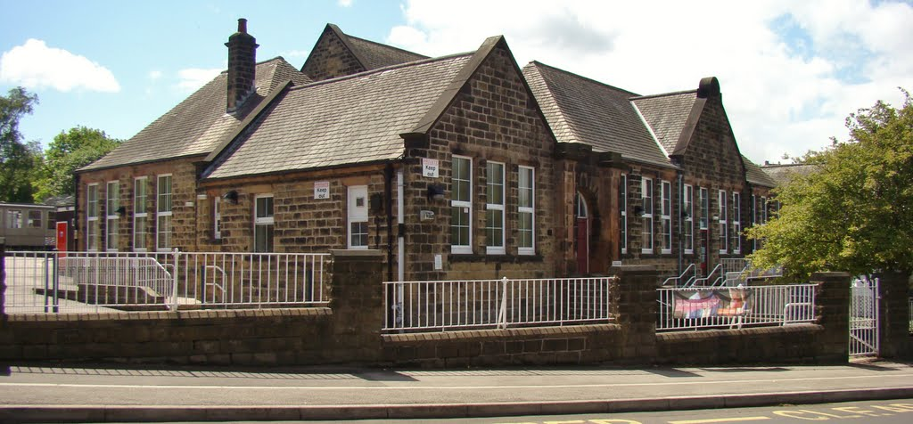

**Welcome to the Monthly Bulletin**

The next issue will be out in November

October 2024

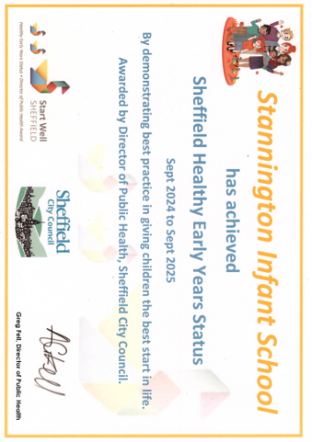

Please remember for snack and lunchtime

No nuts or products containing nuts.

**Water only** in drinks bottles please.

We are delighted to let you know that the school has been awarded **The Healthy Early Years Award.** Well done to Miss Gore and the EYFS team, thank you to the parents who worked on this with school.

The Healthy Early Years award is a quality assurance certification accredited by the Director of Public Health. It recognises and celebrates settings that take a holistic approach to promoting health in early childhood. Covering seven key strands, the award emphasises key public health messages and demonstrates a commitment to supporting the physical, mental, and emotional health and wellbeing of children, families, staff, and the wider community.

Part of our work on this was developing an appropriate snack policy -please see below. We have noticed some snacks being sent in do not adhere to this, please could you only send items listed below. Thank you so much.

**Snacks Policy**

If you are intending to send in healthy snacks with your child please limit them to the list below:-

**Vegetable sticks** – such as celery, cucumber, peppers or carrot, a range of colour ensures different vitamins and minerals. 



A piece of cheddar **cheese** or Babybel



A piece of **fresh or dried fruit,** high in soluble fibre and vitamins would also be a great snack– pineapple, mango, kiwi, plain raisins, apricots, blueberries, banana slices. If you wish to send dried fruit please be aware that dried fruit can often stick to teeth so is recommended for meal times only to reduce the risk of tooth decay.

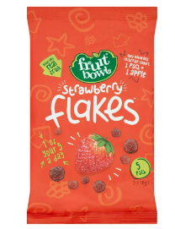

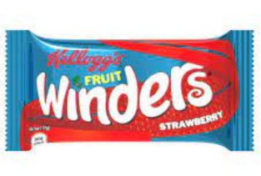No processed fruit snacks please as these can contain high levels of sugar (fruit winders, fruit flakes etc)



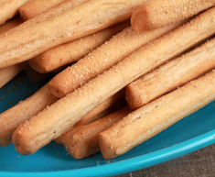Bread sticks, plain pretzels, banana bread, malt loaf, oat/rice cakes and small pitta breads are also good snacks, providing children with carbohydrate to sustain them in-between meals.



We would prefer parents chose not to send cereal bars as many of these are high in sugar or saturated fat content. For example, these have 10g of sugar per bar. 4g of sugar is about a teaspoon /sugar cube. Four to six-year olds should have no more than 19g of sugar per day.

3.10.24 Individual photos

7/8/10 24 Toys workshop (Year 1 and 2)

14.10.24 Christmas card designs come home for parents to order packs (if you wish)

15.10.24 Curriculum meeting for FS parents 6pm school hall

17.10.24 PFA film night – letter to follow

18.10.24 Y2s to Giddy Goat

22.10.24 Parents evening – 1:1 meetings with class teachers, parents only please

23.10.24 PFA Bags to School collection – send unwanted items (please collect in the school car park)

24.10.24 Non uniform day – £1.00 donation to PFA fundraising please

22.10.24 Parents evening – 1:1 meetings with class teachers, parents only please

24.10.24 Parents evening – 1:1 meetings with class teachers, parents only please

25.10.24 Inset Day – no pupils in school

**28.10.24 Half term**

5.11.24 Be Bright Be Seen / Bling your bike or scooter day

7.11.24 / 14.11.24 / 15.11.24 20.22.24 21.11.24 22.11.24 SEND reviews

29.11.24 Christmas Fayre after school

12.12.24 Christmas Jumper Day (NSPCC) £1.00 donation to NSPCC please

13.12.24 Christmas Party day

20.12.24 Non uniform day – £1.00 donation to PFA fundraising please

20.12.24 End of term

**Christmas Performance dates to follow soon**



**Please can you help**

In order to develop the children’s independence at school please could you focus on the following at home

* Fastening coats independently *(when buying new coats try to find ones without double zips or lots of fur around a zip as the children tend to find these harder)*
* Using a knife and fork – please can you focus on using a knife to cut food. Also, if you have jacket potatoes and your child doesn’t eat the skin would you show them how to scoop out the potato.
* Turning the sleeve inside out after taking off a sweatshirt

***Thank you in advance for your help.***

**A final plea for names to be added to clothes. (sweatshirts especially as we already have two full boxes of unnamed ones in lost property)**

**Did you know that our school is one of a small number in the country to have achieved Platinum Modeshift Stars award**

**Road Safety**

During week commencing 21.10.24 we will have **road safety** as our assembly theme. To follow this up we would like to have a **Be Bright Be Seen day on Tuesday 5th November.**

Children should come to school in their uniform but accessorize with bright or reflective clothing to highlight the need to be more visible on dark nights. **Our school council will be handing out prizes to the ‘brightest pupils’**

**Tuesday 5th November** is also **Bling Your Bike and Scooter Day!**

This is a chance to be creative and “dress your bike up” as whatever you want-. You can use paper, stickers, tape, tinsel- basically anything you like to make your bike look as good as you can.

This is to encourage children to travel actively to school. Please remember you still have to ride your bike to school - nothing trailing in the spokes, wheels or on the ground and nothing which will make the bike unstable. Don’t forget to decorate your helmet too!

**There will prizes for the best decorated and most creative bikes.**

We will have a parade of our decorated bikes and scooters to show our class friends.

On arrival at school please can year groups store their bikes in the following areas:-

FS:- at the side of the dining room

Year 1:- at the rear of the Y1 classroom

Year 2:- at the bike /scooter rack area.

The scheme recognises schools that have shown excellence in supporting cycling, walking and other forms of sustainable and active travel.



In addition to this our school has chosen to be part of an exciting nationwide challenge to encourage more children and their families to walk to school. **WOW – the year-round walk to school challenge** is delivered by Living Streets, the UK charity for everyday walking, to help as many children as possible experience the benefits of walking to school.

WOW is a pupil-led initiative where children self-report how they get to school every day. If they travel sustainably (walk, cycle or scoot) one day each week for a month, they get rewarded with a badge. It's that easy!

**What if you can’t walk to school?** If you live too far away or don’t have time to walk the whole way to school, you can Park and Stride to help your child earn their WOW badge. Park or hop off public transport **at least five minutes away** from the school and walk the rest of the way (otherwise this would not be classed as walking to school). Our 5-minute walk zone is on the website <https://www.stanningtoninfants.co.uk/modeshift-stars/>

**Did you know?** The WOW badges are made using excess yoghurt-pot material previously destined for landfill and are produced in the UK, minimising our carbon footprint.

On Tuesday 15th October we will be having a Harvest Assembly in school. **As part of the assembly we would welcome donations for the S6 Foodbank.**

They provide food parcels for people in Stannington, Hillsborough, Crookes, Walkley and surrounding area. Their website is: <https://sheffields6.foodbank.org.uk/>

#### **A typical food parcel includes:**

* Breakfast cereals
* Soup
* Pasta
* Rice
* Pasta sauce
* Tinned beans
* Tinned meat
* Tinned vegetables
* Tinned fruit
* Tea or coffee
* Sugar
* Biscuits
* Snacks

**At the moment the foodbank is more in need of the following items** (but happy to accept any donation with the exception of sugar)

Tinned fruit

UHT Milk

Tined Fish

Toiletries (shampoo, deodorant, shower gel, toothpaste, toilet roll)

Tinned tomatoes

*Sheffield S6 Foodbank*

*Food and Community Trust*

*66 Cross Bedford Street Sheffield*

*S6 3BQ*

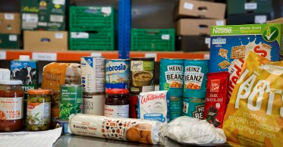

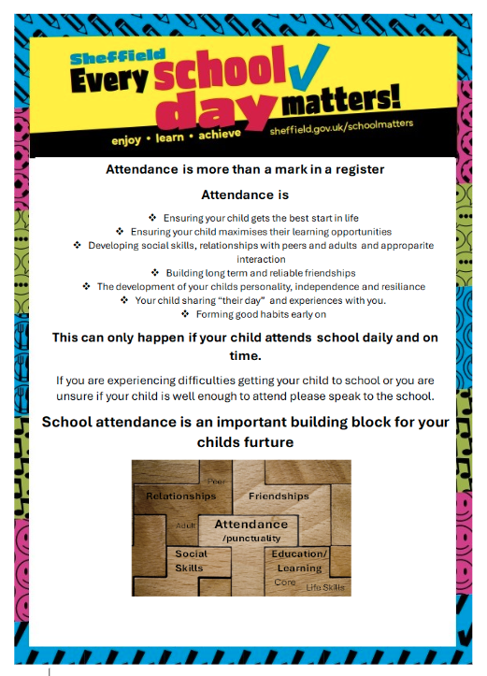

**Stannington Infant School’s**

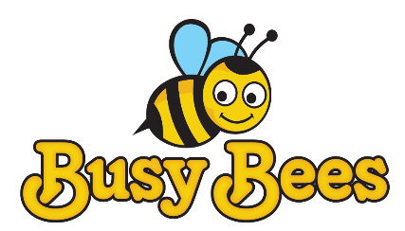

**Breakfast and After School Club**

**Breakfast Club** Monday to Friday 7.30 – 8.50am

**After School Club** Monday to Friday 3.15 – 5.45pm

We provide excellent wrap around provision within a safe and happy environment.

The sessions are charged at £5 for breakfast club which is open from 7.30 am. Each child will receive a healthy breakfast and a drink with quiet space and activities so they are ready for the start of school. Children will be accompanied to the classroom 8.40 am ready for registration.

After school club is available from 3.15pm until 5.45pm, the sessions are charged at £8.50. The children will have access to both indoor and outdoor facilities, making use of our wonderful school grounds. Indoor activities include craft, colouring, baking, whilst outdoors children will have balance bikes, gardening or sporting fun. A healthy snack will be available e.g. fruit or vegetables, toast, smoothies or milk.

All bookings must be made using the Parentmail app booking system and you must use the PAY NOW option unless you are using childcare vouchers in which case you may use the PAY LATER option. All bookings must be paid for upfront and you will receive a refund if you cancel 48 hours in advance.

We have 20 places and cannot accommodate more children at this time. Places will only be allocated upon receipt of the registration form.

Please note that spaces are limited so ensure you request a place in plenty of time.

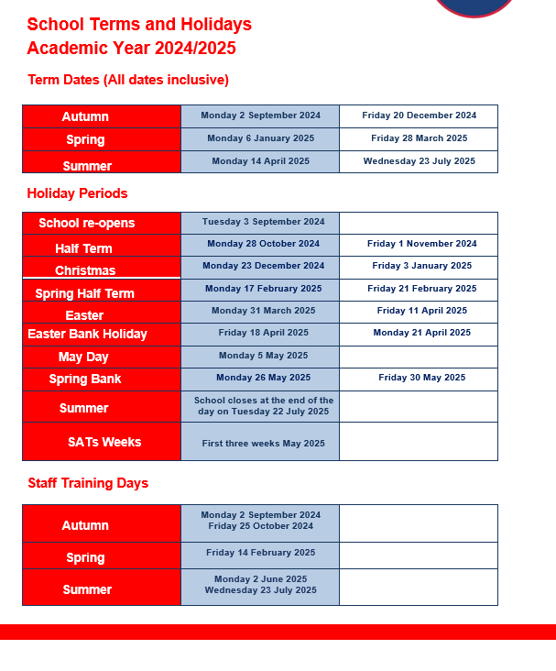

**Contact us ……. Stannington Infant SchoolStannington Road, Sheffield, S6 6AN**

**Telephone: 0114 2344401 Headteacher: Sarah Binns**

**Fax: 0114 2334724 Deputy Headteacher: Liz Harris**

**Email:** [**enquiries@stannington.sheffield.sch.uk**](mailto:enquiries@stannington.sheffield.sch.uk) **Chair of Governors: Charlotte Surridge**

**Website: www.stanningtoninfants.co.uk**