

**Welcome to the Monthly Bulletin**

The next issue will be out in December

November 2024

Our new school menu starts after half term and runs until Easter. It is a three week rotation of the menu on the following dates

**Week One** 11th Nov / 2nd Dec /13th Jan / 3rd Feb / 24th Feb / 17th Mar

**Week Two** 18th Nov / 9th Dec / 20th Jan / 10th Feb / 3rd Mar / 24th Mar / 14th Apr

**Week Three** 4th Nov / 25th Nov / 16th Dec / 6th Jan / 27th Jan / 10th Mar

The menus can be found on the school website here

<https://www.stanningtoninfants.co.uk/menus-school-fruit-and-vegetable-scheme/>

**Please, please, please can we ask that sweatshirts are named as we already have two full boxes of lost property.**

**28.10.24 Half term**

5.11.24 Be Bright Be Seen / Bling your bike or scooter day

6/7.11 24 Geography days - don’t forget to do the Geography trail after school.

7.11.24 / 14.11.24 / 15.11.24 20.22.24 21.11.24 22.11.24 SEND reviews

8.11.24 Y2 pupils (small group) to Sheffield Book Awards Ceremony

11.11.24 Flu Vaccines

12.11.24 Y2 Family workshop 1-3pm

15.11.24 Children in Need day – wear spots! Merchandise available to buy in school.

19.11.24 Skipathon

28.11.24 Tutt Frutti theatre – The Glass Slipper (all classes watching)

29.11.24 Christmas Fayre after school

12.12.24 Christmas Jumper Day (NSPCC) £1.00 donation to NSPCC please

13.12.24 Christmas Party day

16.12.24 FS Vision Screening

18.12.24 Making Christingles

18.12.24 Christmas Dinner for pupils

19.12.24 Christingle service Christchurch

20.12.24 Non uniform day – £1.00 donation to PFA fundraising please

20.12.24 End of term

**Christmas Performance dates have been sent on our Christmas newsletter**

***Inset days 2025/26***

*Monday 1st September 2025*

*Friday 24th October 2025*

*Friday 13th February 2026*

*Monday 1st June 2026*

*Monday 20th July 2026*



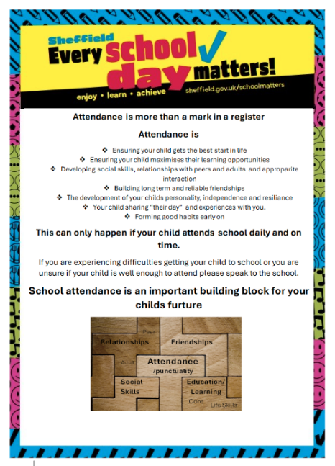

**Attendance reminders**

The school policy is on the website.

If half a day term time leave is taken this will be from 1pm and children will not receive the attendance mark for the afternoon.

If a child is absent from school due to illness but subsequently then goes on holiday this will be recorded as an unauthorised holiday.



**Road Safety**

During week commencing 21.10.24 we will have **road safety** as our assembly theme. To follow this up we would like to have a **Be Bright Be Seen day on Tuesday 5th November.**

Children should come to school in their uniform but accessorize with bright or reflective clothing to highlight the need to be more visible on dark nights. **Our school council will be handing out prizes to the ‘brightest pupils’**

**Tuesday 5th November** is also **Bling Your Bike and Scooter Day!**

This is a chance to be creative and “dress your bike up” as whatever you want-. You can use paper, stickers, tape, tinsel- basically anything you like to make your bike / scooter look as good as you can.

This is to encourage children to travel actively to school. Please remember you still have to ride your bike /scooter to school - nothing trailing in the spokes, wheels or on the ground and nothing which will make the bike unstable. Don’t forget to decorate your helmet too!

**There will prizes for the best decorated and most creative bikes or scooters.**

We will have a parade of our decorated bikes and scooters to show our class friends.

On arrival at school please can year groups store their bikes in the following areas:-

FS:- at the side of the dining room

Year 1:- at the rear of the Y1 classroom

Year 2:- at the bike /scooter rack area.

**Please can you help**

Next half term we are focusing on kindness and good manners. Each class has elected a Good Manners Champion who will model these expectations.

We are focusing on

* Saying hello or good morning to adults
* Saying please and thank you
* Saying excuse me to get an adults attention

Our Good Manners Champions have badges like this to wear 

Please would you encourage your children with this, thank you.

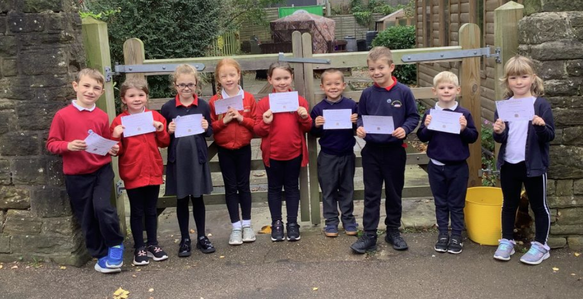



Meet Eco Club!

They will be working with Miss Travis and Mrs Platts this year on sustainability across school.

We are hoping to achieve the Eco schools Award. We will keep you updated and hopefully families will be able to get involved in the work.

**The National Sleep Helpline 03303 530 541**

The National Sleep Helpline helps anyone with sleep issues including adults, parents and young people. The helpline is available from 7pm and 9pm, Sunday to Thursday on 03303 530 541.

Poor sleep can affect anyone and it can be a major stress for parents whose own sleep can be impaired by their children's difficulties getting to sleep, staying asleep or staying in their own bed, leading to greater stress.

Having a sleep issue is surprisingly common. At any given time this affects up to 40% of adults and 50% of children (this rises to 80% with a SEND diagnosis). These problems are typically persistent and do not resolve themselves without intervention.

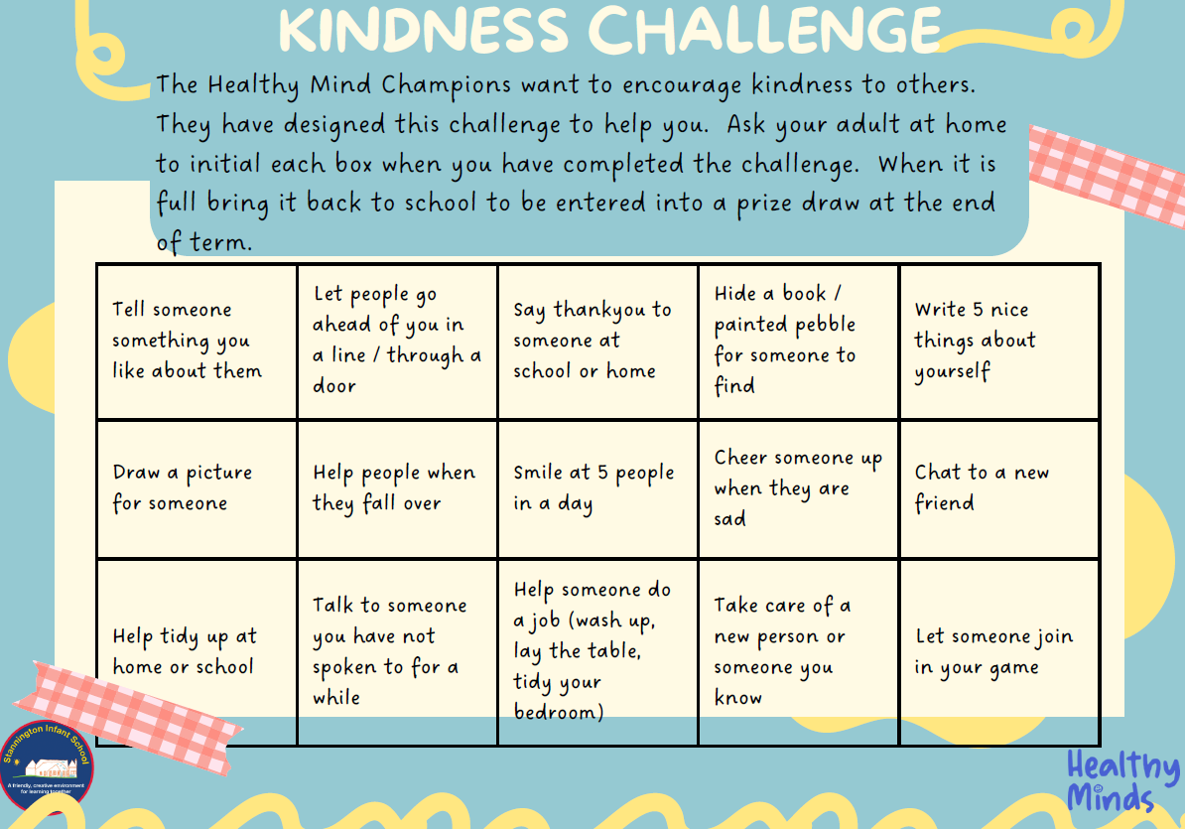

Our Healthy Minds Champions have designed a kindness challenge for all the children in school.

We would love families to support the children with this please,

let’s share lots of kindness!

Please return forms by Friday 6th December.

A paper copy will be sent home on 4th November.

**Stannington Infant School’s**

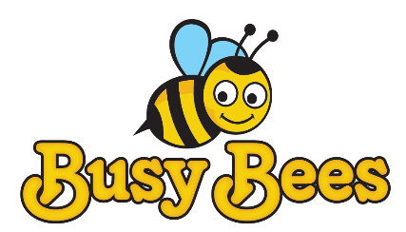

**Breakfast and After School Club**

**Breakfast Club** Monday to Friday 7.30 – 8.50am

**After School Club** Monday to Friday 3.15 – 5.45pm

We provide excellent wrap around provision within a safe and happy environment.

The sessions are charged at £5 for breakfast club which is open from 7.30 am. Each child will receive a healthy breakfast and a drink with quiet space and activities so they are ready for the start of school. Children will be accompanied to the classroom 8.40 am ready for registration.

After school club is available from 3.15pm until 5.45pm, the sessions are charged at £8.50. The children will have access to both indoor and outdoor facilities, making use of our wonderful school grounds. Indoor activities include craft, colouring, baking, whilst outdoors children will have balance bikes, gardening or sporting fun. A healthy snack will be available e.g. fruit or vegetables, toast, smoothies or milk.

All bookings must be made using the Parentmail app booking system and you must use the PAY NOW option unless you are using childcare vouchers in which case you may use the PAY LATER option. All bookings must be paid for upfront and you will receive a refund if you cancel 48 hours in advance.

We have 20 places and cannot accommodate more children at this time. Places will only be allocated upon receipt of the registration form.

Please note that spaces are limited so ensure you request a place in plenty of time.

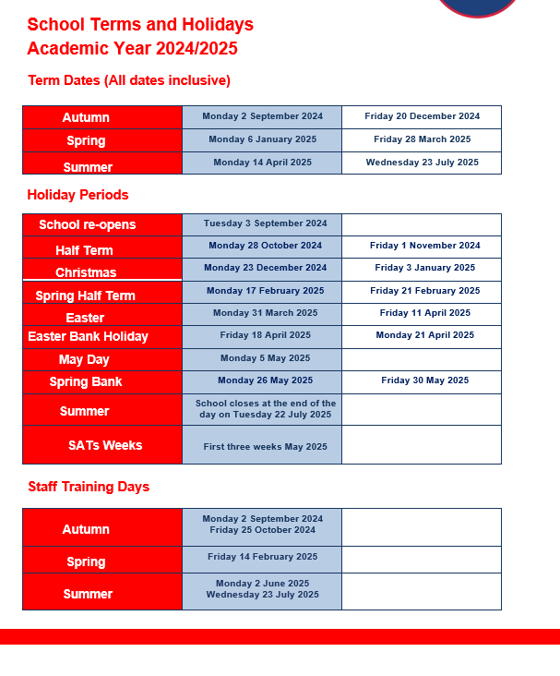

**Contact us ……. Stannington Infant SchoolStannington Road, Sheffield, S6 6AN**

**Telephone: 0114 2344401 Headteacher: Sarah Binns**

**Fax: 0114 2334724 Deputy Headteacher: Liz Harris**

**Email:** [**enquiries@stannington.sheffield.sch.uk**](mailto:enquiries@stannington.sheffield.sch.uk) **Chair of Governors: Charlotte Surridge**

**Website: www.stanningtoninfants.co.uk**