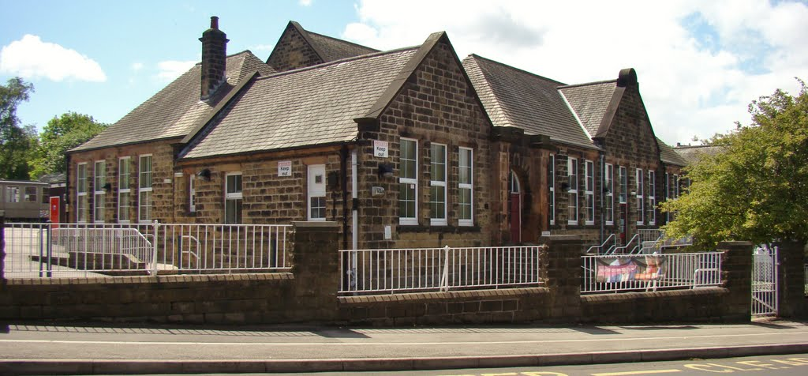

**Welcome to the Monthly Bulletin**

The next issue will be out in January

December 2024

Thank you to all families for supporting the Children in need fundraising and a super well done to School Council for the very popular bun sale!

These are the amounts we raised.

Bun Sale £163.15

Wear Spots £116.17

Merchandise £322.00



Thank you to the Parents Fundraising Association for running our wonderful Christmas Fayre, we hope that you enjoyed it. Thanks also to the band for the carols and to everyone who came to help.



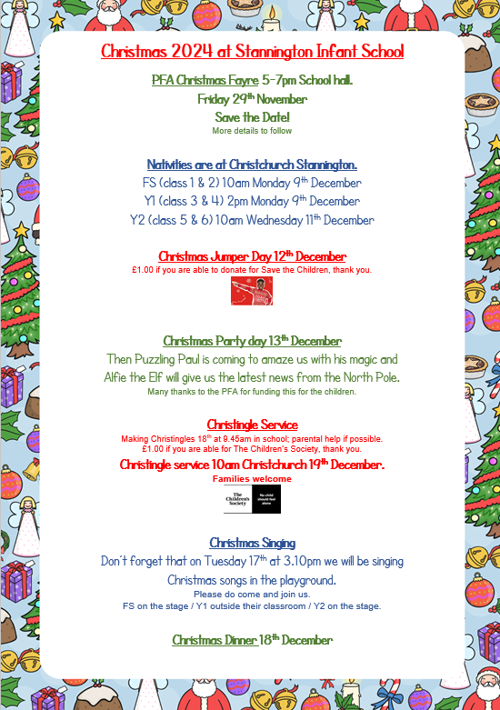

No tickets needed. Capacity at the church is 200 seats (NB some seating upstairs.) **Please be considerate of all families when deciding how many adults will attend.**

*(60 children per performance)*

Christmas party day lunch menu is

Can you help making Christingles on 18.12.24 at 9.45am?

£1.00 for the Children’s Society

Families welcome at the service. Capacity at the church is 200 seats (NB some seating upstairs.)

******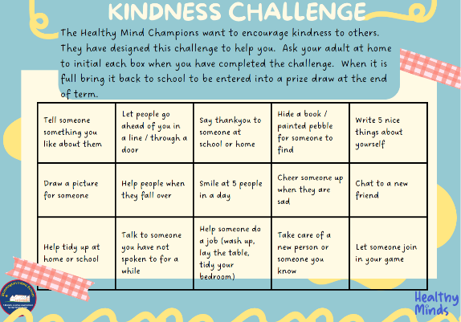

Don’t forget to return your kindness challenge sheet by

**by Friday 6th December.**

**If your child wishes to send Christmas cards please ask them to post them in the post box next to the Christmas tree (in the main hall).**

**Please ensure class numbers are put on each card as the children sort and deliver them. Thank you**



**Our school Christmas tree (real) will be available to a family on Friday 20th December. If you would like to reserve this please phone the school office on 0114 2344401. We would love to find it a home for Christmas day!**

**Nb you will need to transport it to your home.**

Some reminders……………..

We have some cake containers left after the Christmas Fair – in the school office. Please would you pop in to collect them, thank you.

Also, we have lost property mounting up again – please do pop into the cloakroom to collect items.

Please can we remind families to name every item of clothing (including hats, gloves and scarves) Thank you

**Applications for Reception 2025/ 26**

The online site closes on 6th December 2024

Closing date for paper applications 15th January 2025

Offer date April 16th 2025

**Stannington Infant School’s**

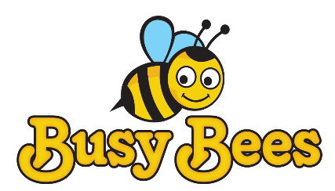

**Breakfast and After School Club**

**Breakfast Club** Monday to Friday 7.30 – 8.50am

**After School Club** Monday to Friday 3.15 – 5.45pm

We provide excellent wrap around provision within a safe and happy environment.

The sessions are charged at £5 for breakfast club which is open from 7.30 am. Each child will receive a healthy breakfast and a drink with quiet space and activities so they are ready for the start of school. Children will be accompanied to the classroom 8.40 am ready for registration.

After school club is available from 3.15pm until 5.45pm, the sessions are charged at £8.50. The children will have access to both indoor and outdoor facilities, making use of our wonderful school grounds. Indoor activities include craft, colouring, baking, whilst outdoors children will have balance bikes, gardening or sporting fun. A healthy snack will be available e.g. fruit or vegetables, toast, smoothies or milk.

All bookings must be made using the Parentmail app booking system and you must use the PAY NOW option unless you are using childcare vouchers in which case you may use the PAY LATER option. All bookings must be paid for upfront and you will receive a refund if you cancel 48 hours in advance.

We have 20 places and cannot accommodate more children at this time. Places will only be allocated upon receipt of the registration form.

Please note that spaces are limited so ensure you request a place in plenty of time.

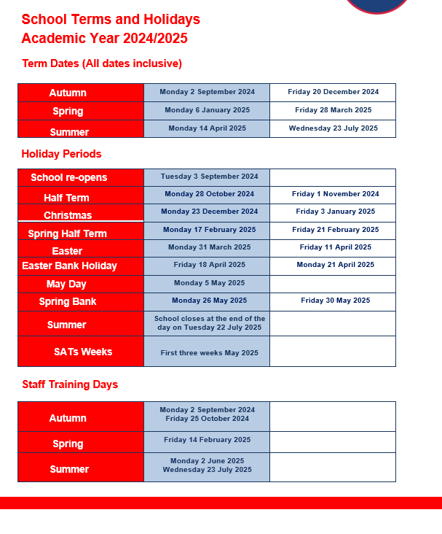

**Contact us ……. Stannington Infant SchoolStannington Road, Sheffield, S6 6AN**

**Telephone: 0114 2344401 Headteacher: Sarah Binns**

**Fax: 0114 2334724 Deputy Headteacher: Liz Harris**

**Email:** [**enquiries@stannington.sheffield.sch.uk**](mailto:enquiries@stannington.sheffield.sch.uk) **Chair of Governors: Charlotte Surridge**

**Website: www.stanningtoninfants.co.uk**