**Key vocabulary**

**Historian** – a person who finds out about past events and people.

**Artefacts** – objects from the past Source – Where something comes from or where it can be found

**Event** – something that has happened or will happen.

**Explorer** - a person who explores a new or unfamiliar.

**Figure** – a well-known or important person

**Recount** – telling someone about an event or experience

**Effect** – something that happened because of something else

**Sequence of events** – things that have happened in order

**Periods** – a length of time

**Timeline** – a line to show the order in which events happened

**Cause** - why something happened

**Reliability** – How much you can trust something/someone.

**Significant** – important

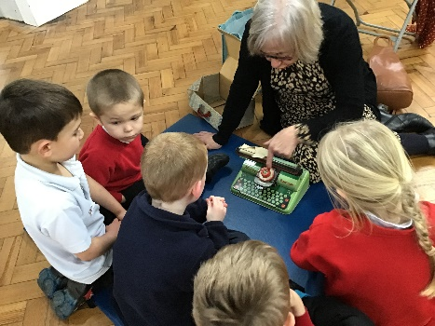

Please contact the following person for any additional information:

**Paula Greensmith**

**History Co-ordinator**

Stannington Infant School

Stannington Road

Sheffield

S6 6AN

Stannington

Infant

School

History

Information Leaflet for

Parents and Carers

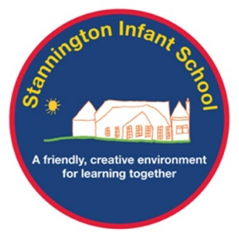



**Foundation Stage:**

In Foundation Stage children will begin to learn about the concepts of past and present. They will learn about toys from the past and investigate what toys were like when their parents and grandparents were little. Children will begin to learn about how they have changed over time.

**Key stage 1:**

During Key Stage 1 our children will learn how to investigate the past, they will look at artefacts, research using internet and books. They will gather and look at accounts from people and begin to discuss the reliability of these. Children will learn about key events and they will learn to sequence these on a timeline. Children will enjoy immersive experiences to experience what life was like in the past. Children will develop an understanding of cause and effect.

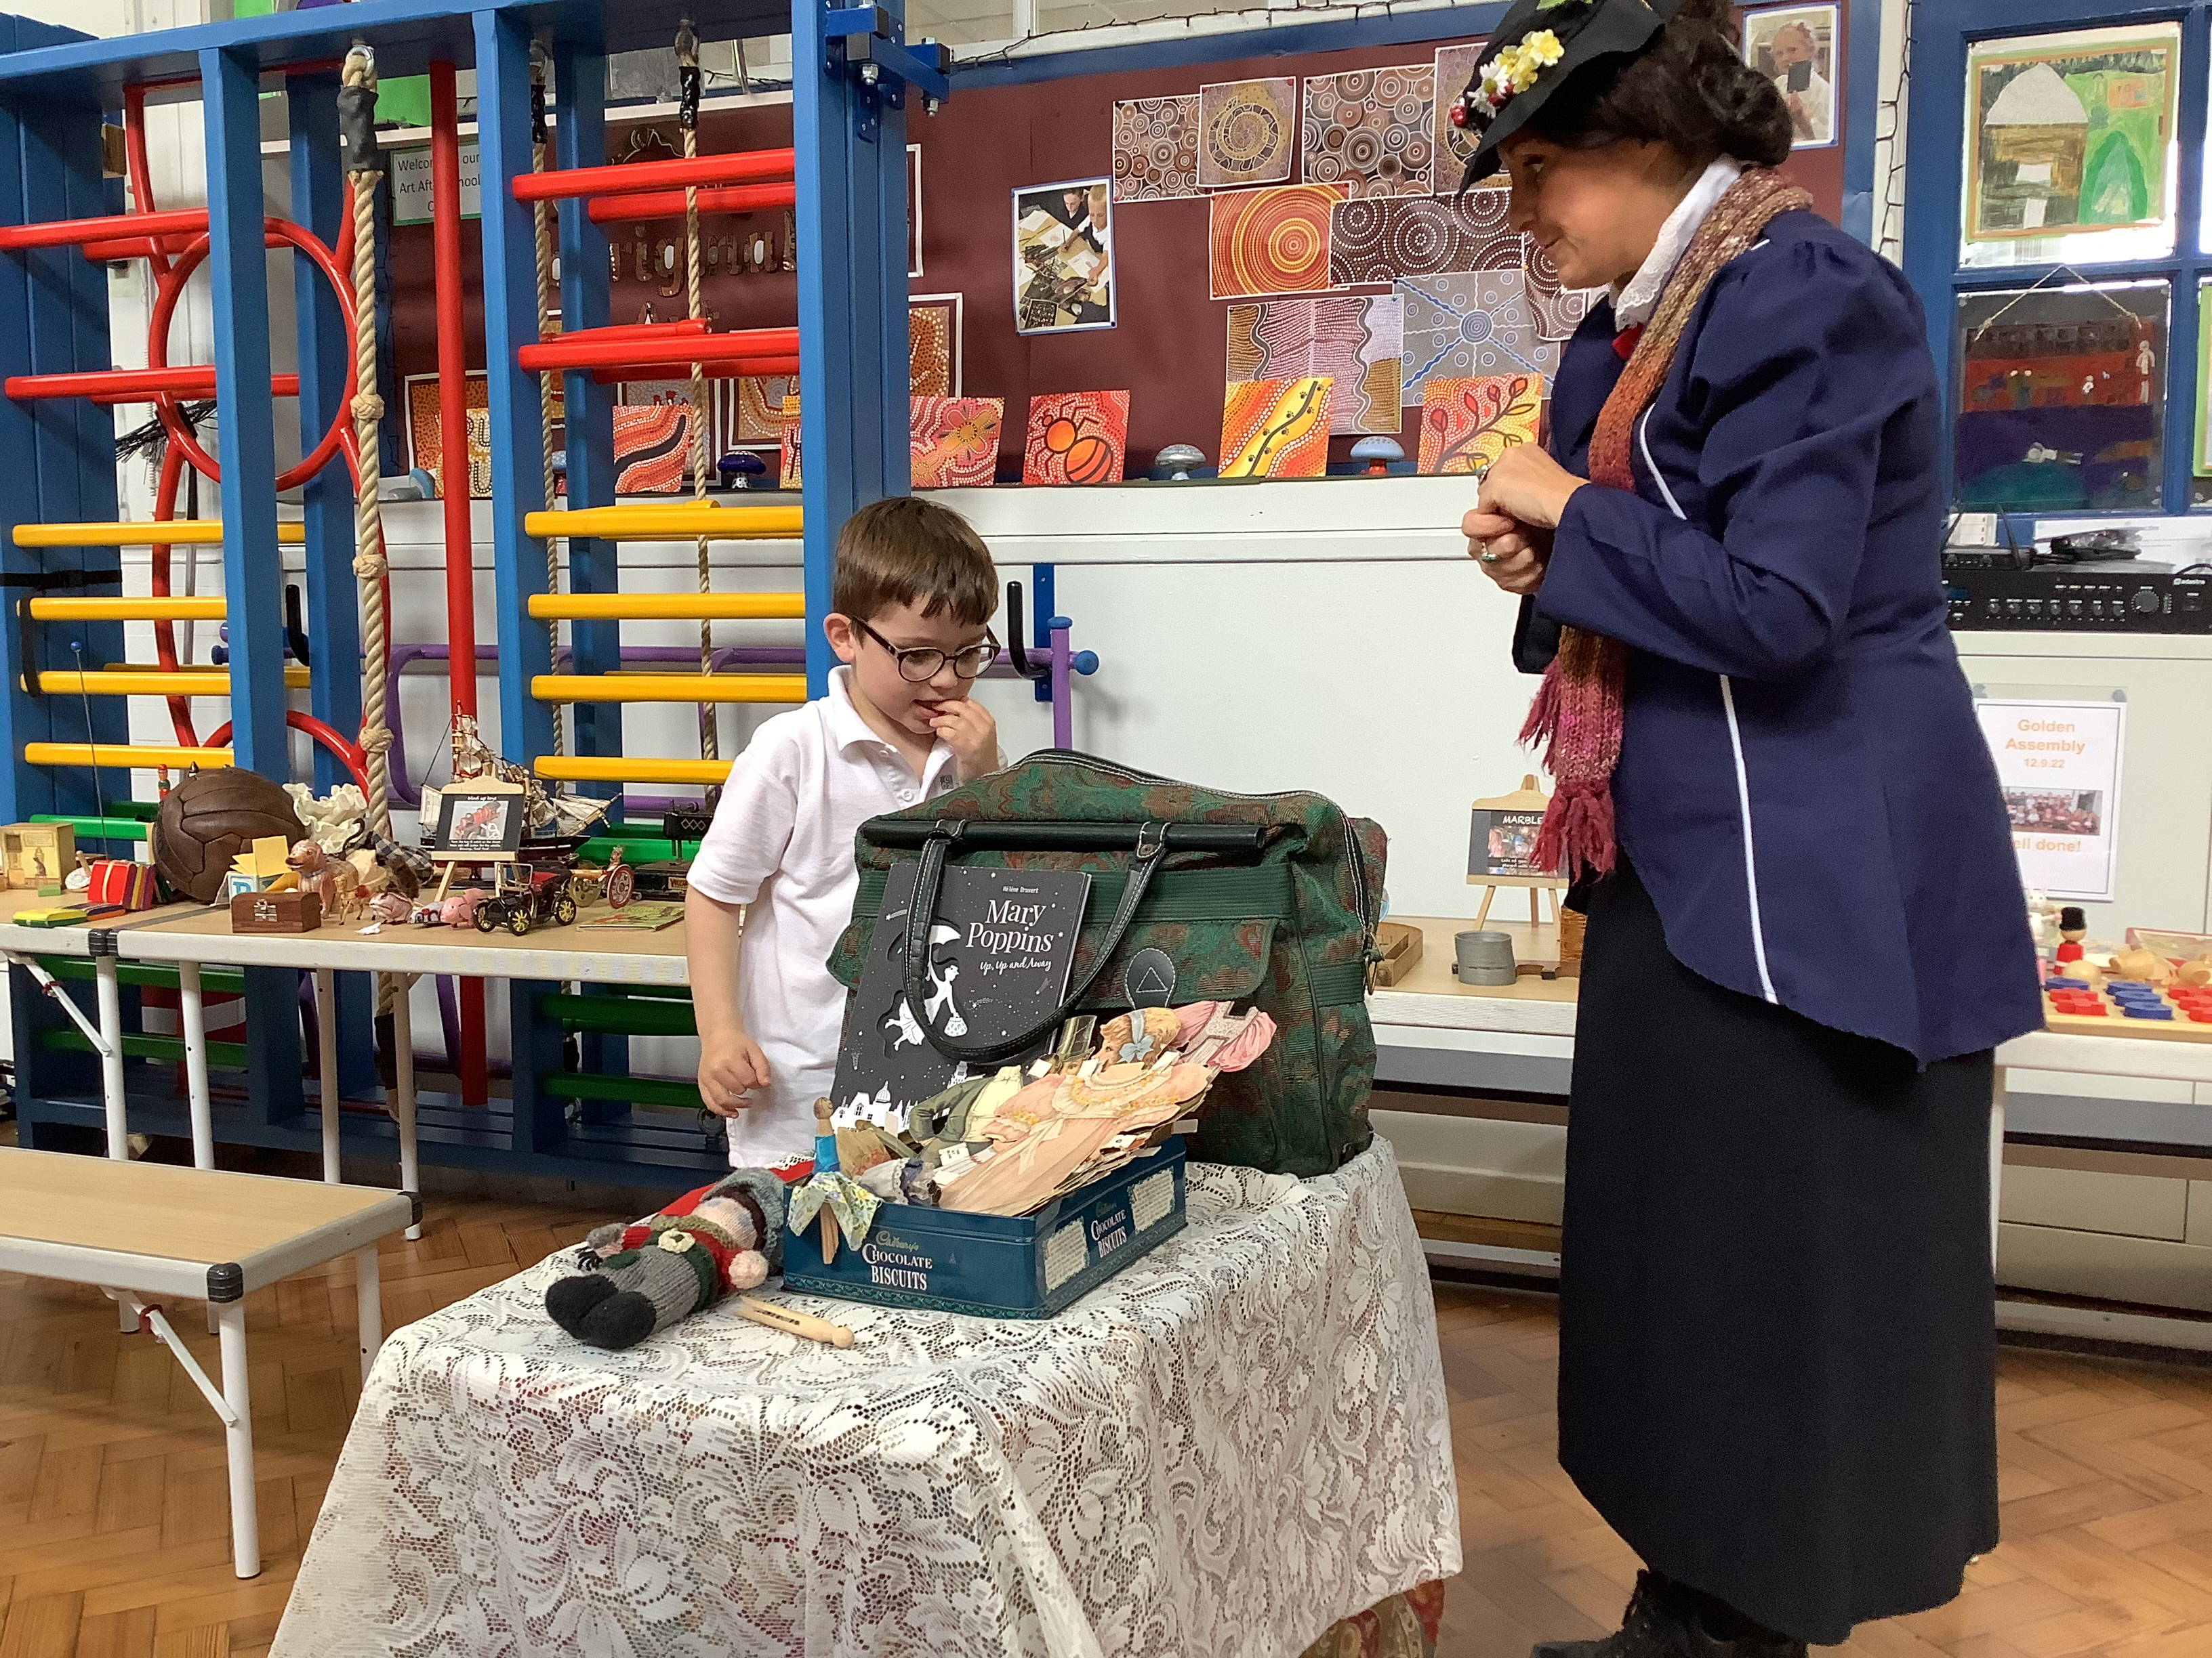

**History at**

**Stannington Infant School**

History is the study of people, events and places from the past. Comparing these to those of today and how these have affected our lives today.

We aim to foster an active interest and curiosity about the past, and to develop an understanding that enables them to enjoy all that history has to offer.

Lessons enable children to see and appreciate how things have changed over time and will continue to change, and to understand how the past differs from the present. Children learn develop a sense of chronology and to know about significant events in British history.

Children learn about their own history before beginning to gain knowledge and understanding of historical development in the wider world.

We aim to help children to develop the skills of enquiry, investigation, analysis, evaluation and presentation – using a wide range of sources to find out about the past and asking questions: How? When? Why? Who? What?

**What will children learn?**

**Your child will have a knowledge builder which you can refer to for specific topics that they are learning at that time. Here are some general ideas to support children’s understanding of historical concepts.**

**Ask your child who they could ask about life in the past. Perhaps they can ask an older relative or neighbour. Children gain so much understanding about sources of evidence when they are able to gather first hand accounts of their own.**

**Share any old artefacts you may have with your child. (an old teddy/toy/object) Allowing children to investigate any objects you may have from the past will deepen their understanding of how we find out about the past.**

**While you are out and about talk to your child about the buildings that you can see. Which are old and new and how can you tell? If you visit the city centre can you compare the town hall to the newer buildings and talk about how you know which are older.**

**Share any old photographs that you might have of yourself, your child or your local area. Can you discuss the changes that have happened over time?**

**How can you support this learning at home?**